June 1, 2018

Letter of Invitation from the 1st International Forum on Rice Development

Dear Sir or Madam:

In order to boost the development and industry revitalization of international rice research and strengthen international academic exchanges, “The First International Forum on Rice Development” will be held in September 2018 at Changsha, China.

The theme of this forum is World Rice Development and Industrial Revitalization. The main issues include: world rice development history and prospect; world rice culture and inheritance; breeding and development of new rice varieties; the innovative development and benefit of rice farming model; multiple cropping rice farming system development; innovation and progress of rice machinery; development of seed industry for the promotion of rice industry; revitalization of rice industry; world rice trade and exchanges.

The forum is directed by People’s Government of Hunan Province and sponsored by People’s Government of Changsha City, China National Hybrid Rice Research and Development Center, The Crop Science Society of Hunan, and Yuan Longping Agricultural Science and Technology Award Foundation. The Directorate of International Forum on Rice Development will be established during this forum. On behalf of the forum, I sincerely invite you to hold a post in the Directorate and attend the forum. Please contact the organizing committee if you are going to attend the forum.

Contact person: Ms. Yeyun Xie & Mi Weiwei;
Phone: 15580070348; Email: xinyeyun@hhrrc.ac.cn; gjdzlt@163.com

We look forward to seeing you in Changsha, China.
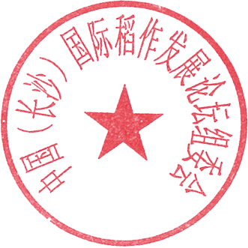
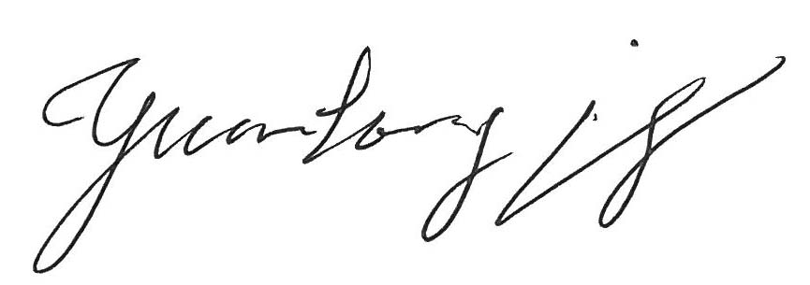
Yours sincerely,

Yuan Longping
Organizing Committee of the First International Forum on Rice Development

